SQL TD3

1. SELECT nom_type_hebergement FROM type_hebergement;

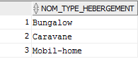

1. SELECT nom_zone FROM zone;

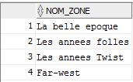

1. SELECT * FROM habitation;

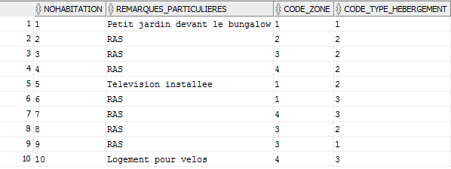

1. SELECT nom_type_hebergement FROM type_hebergement WHERE nombre_de_place>4;

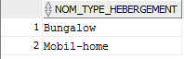

1. SELECT nohabitation FROM habitation WHERE code_zone=4;

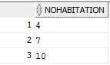

1. SELECT nom_zone, code_zone FROM zone WHERE nom_zone LIKE ‘le%’;



1. SELECT nohabitation, nom_zone FROM habitation hab, zone zo WHERE hab.code_zone=zo.code_zone;

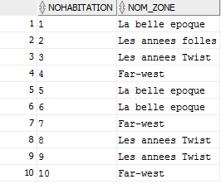

1. SELECT nom_equipement FROM equipement eq, type_hebergement tyh, possession po WHERE po.code_equipement=eq.code_equipement AND tyh.nom_type_hebergement='Bungalow';

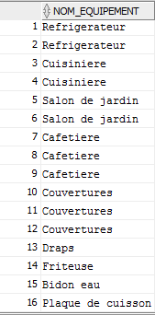

1. SELECT nohabitation, nombre_de_place FROM habitation hab, type_hebergement tyh WHERE hab.code_type_hebergement=tyh.code_type_hebergement;

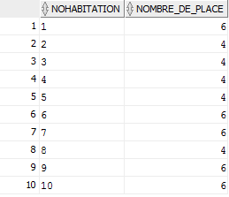

1. SELEcT nombre_de_place FROM type_hebergement tyh, habitation hab, zone zo WHERE tyh.code_type_hebergement=hab.code_type_hebergement AND hab.code_zone=zo.code_zone AND nom_zone=’Far-west’;

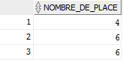

1. SELECT MIN(nombre_de_place) FROM type_hebergement;



1. SELECT MAX(nombre_de_place) FROM type_hebergement;



1. SELECT COUNT(nohabitation) FROM habitation;



1. SELECT COUNT(nohabitation) FROM habitation hab, zone zo WHERE hab.code_zone=zo.code_zone AND nom_zone=’Far-west’;

